DESCRIPTION

You are working as a database administrator for an IT firm. You have been asked to create a new database instance on AWS cloud and connect it with the employee management portal hosted on a web server.

**Background of the problem statement:**

Your organization wants to deploy a new multi-tier application. The application will take live inputs from the employees and it will be hosted on a web server running on the AWS cloud.

The development team has asked you to set up the web server and configure it to scale automatically in cases of a traffic surge, to make the application highly available. They have also asked you to take the inputs from the employees and store them securely in the database.

**You must use the following:**

* Create a Database Instance with the following specifications:
  + Database creation method: Standard Create
  + Engine: MySQL
  + Database Instance size: db.t2.micro

* Create an EC2 Instance with the following specifications:
  + AMI: Amazon Linux
  + Region: Use only US East (N Virginia), us-east-1, and us-east-2
  + Instance types: t2.micro and t3.micro
  + Allowed EBS types: GP2 and Standard

Please follow the below steps to accomplish the above requirement

1. Create Security group ( LBSG ) for load Balancer

Note: Allow http from anywhere

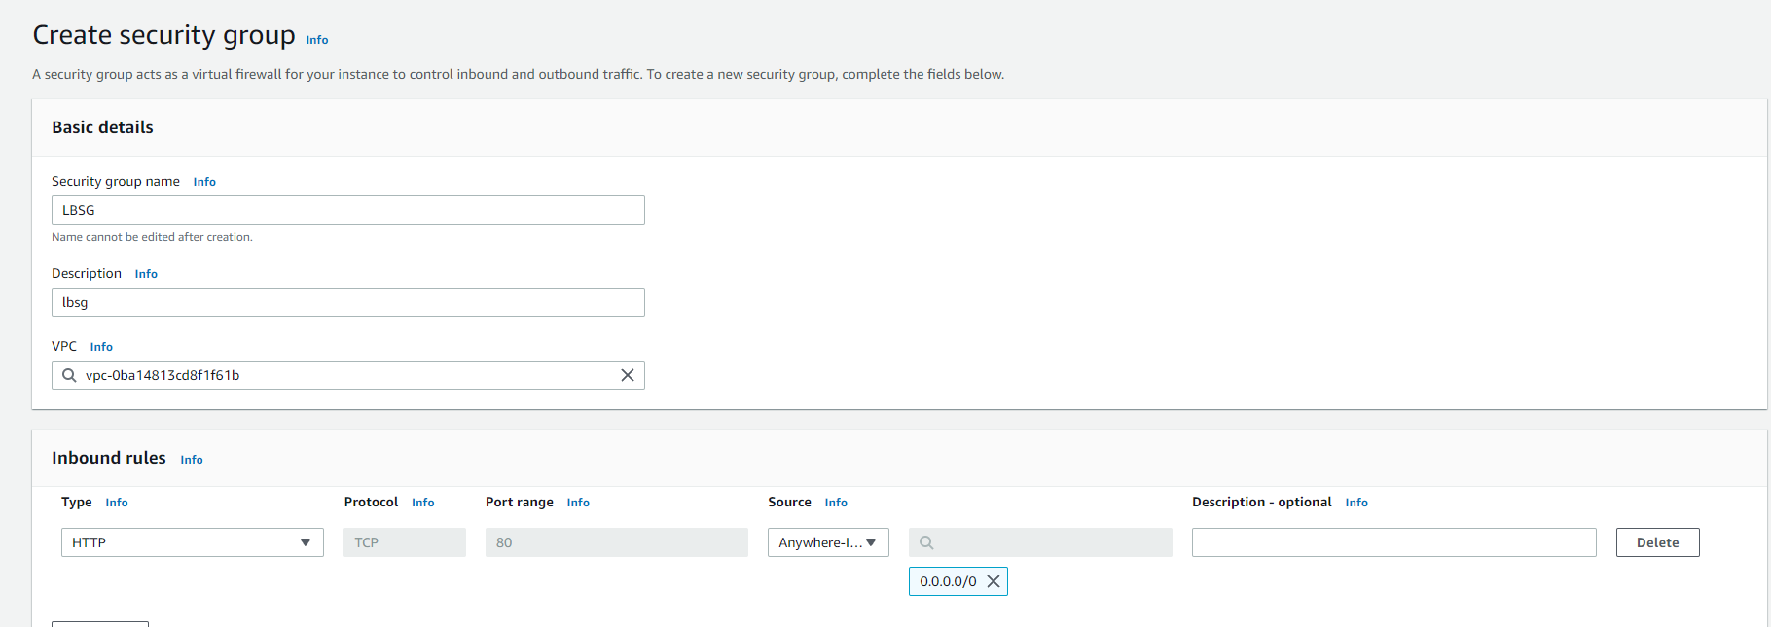

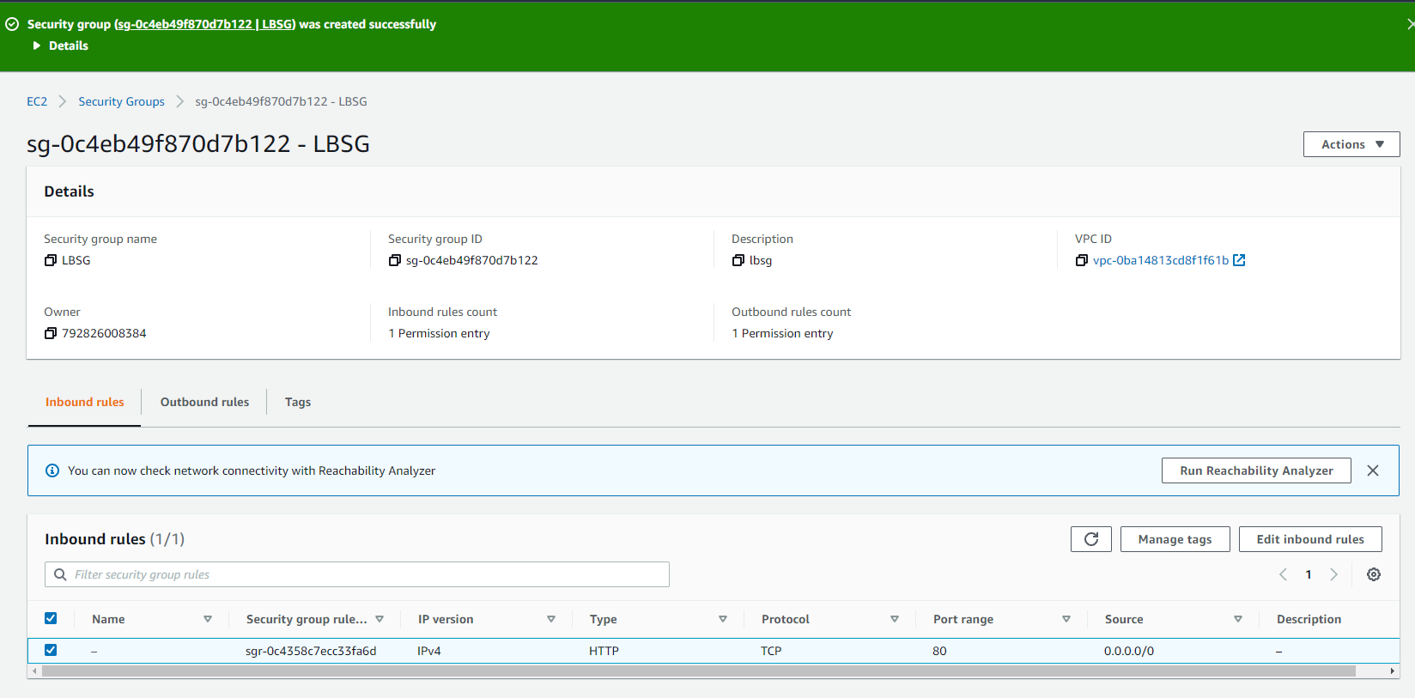

1. Create Security group websg for EC2 Instances to allow traffic coming from Load Balancer

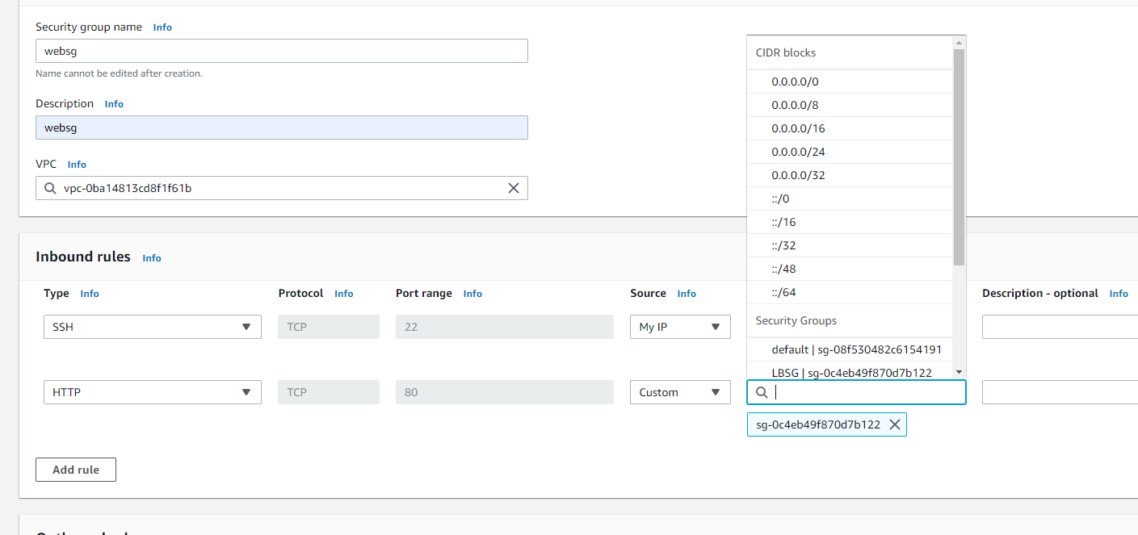

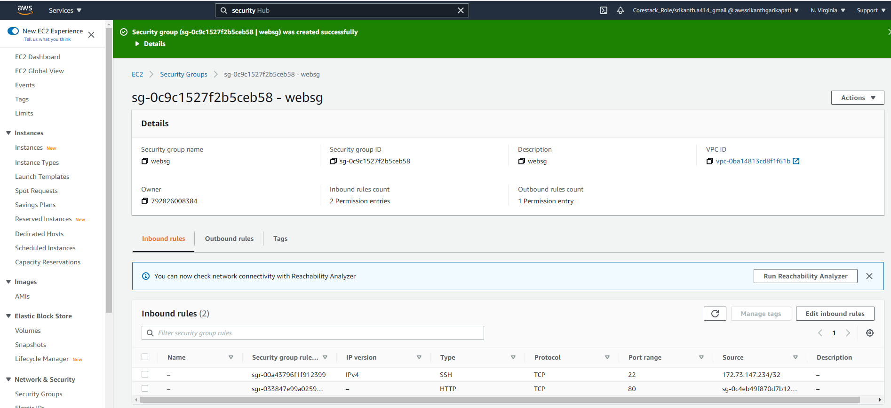

1. Create security group rds for mysql to allow traffic from EC2 instances:

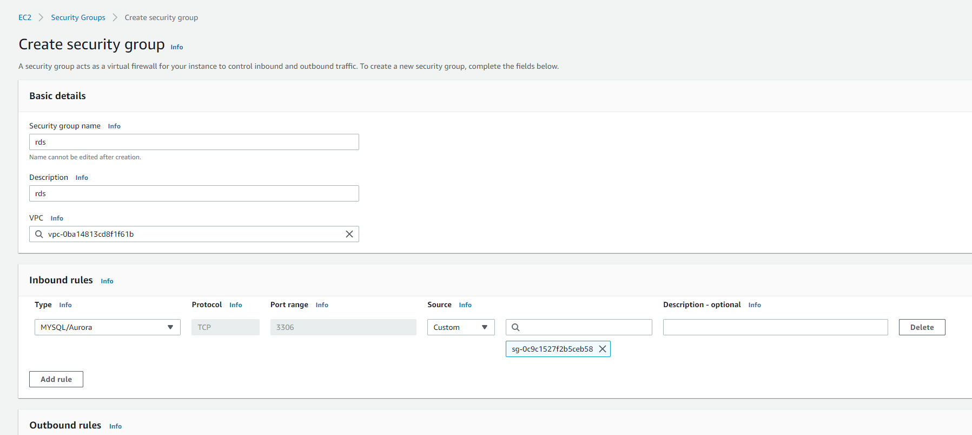

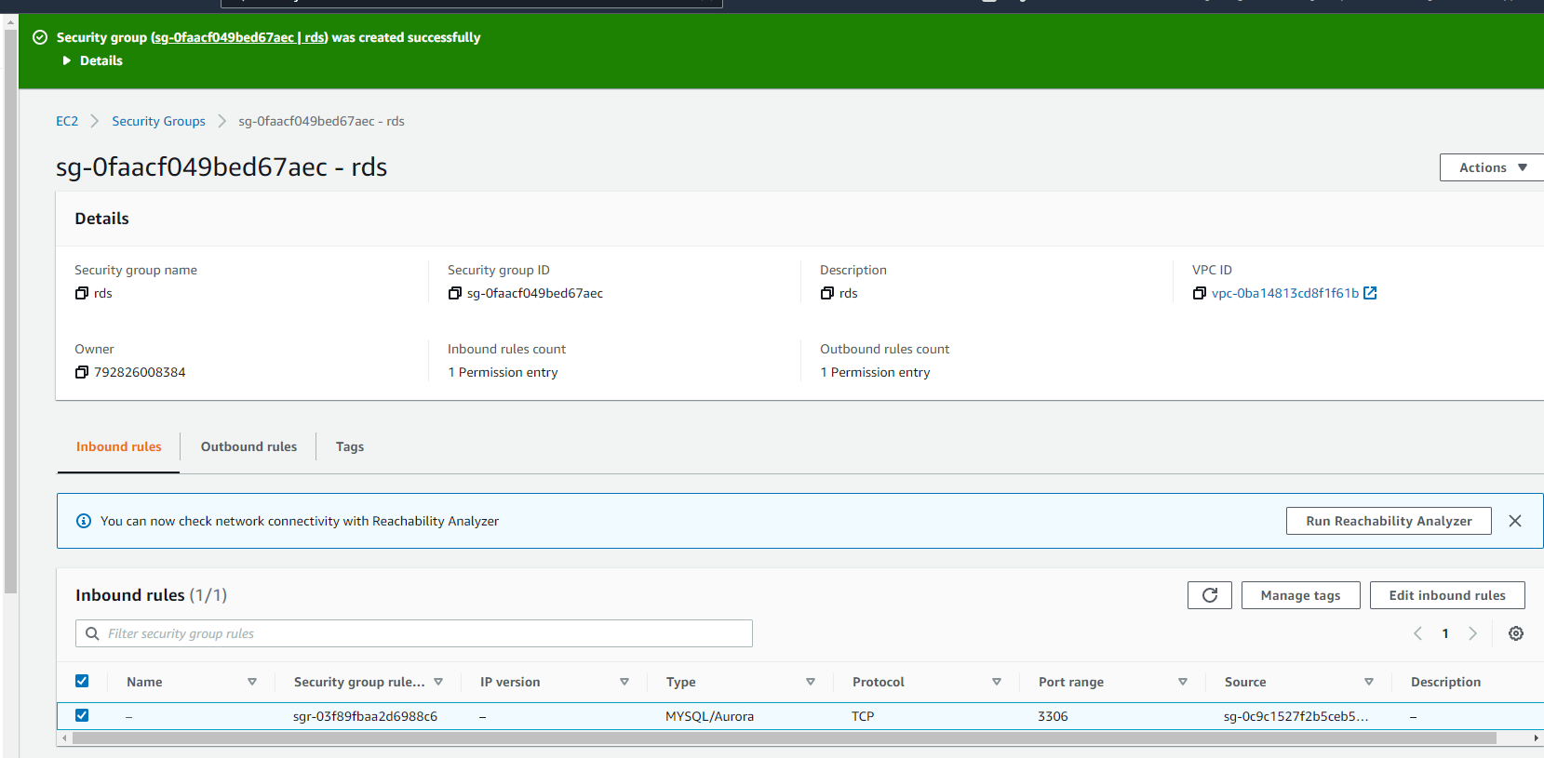

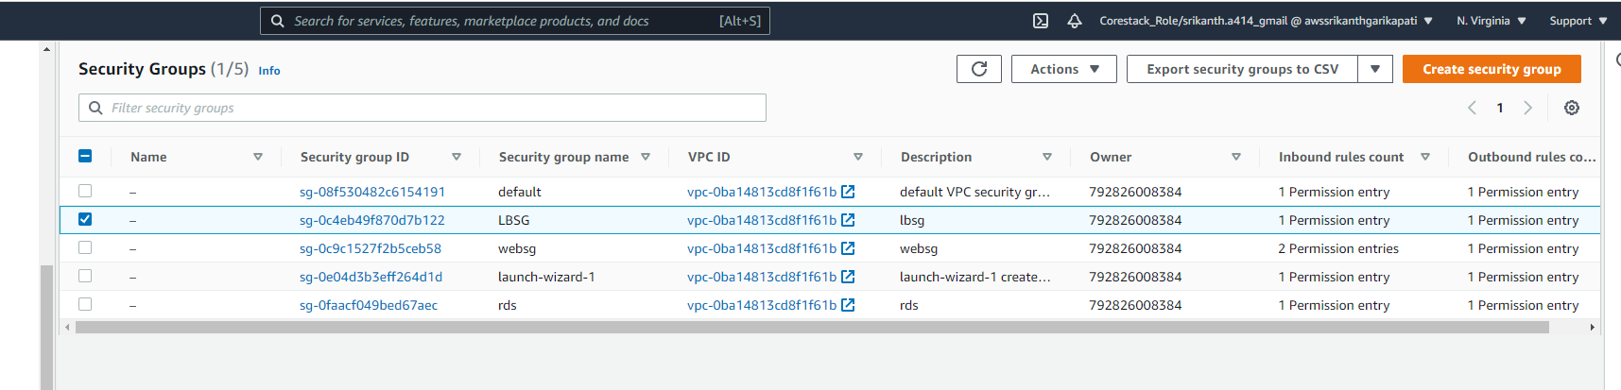

1. Create RDS Database with rds security group:

Choose MySql as your database

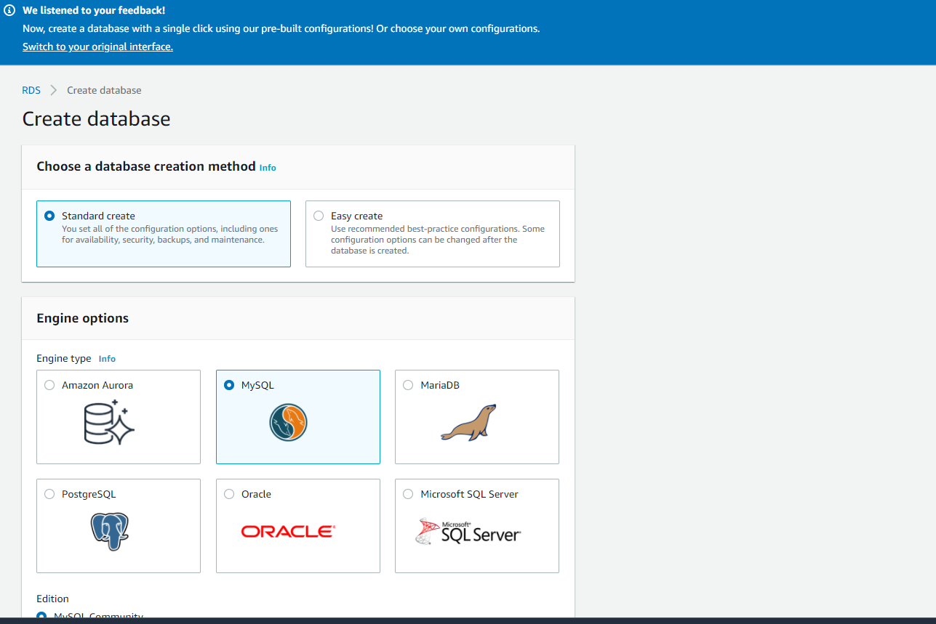

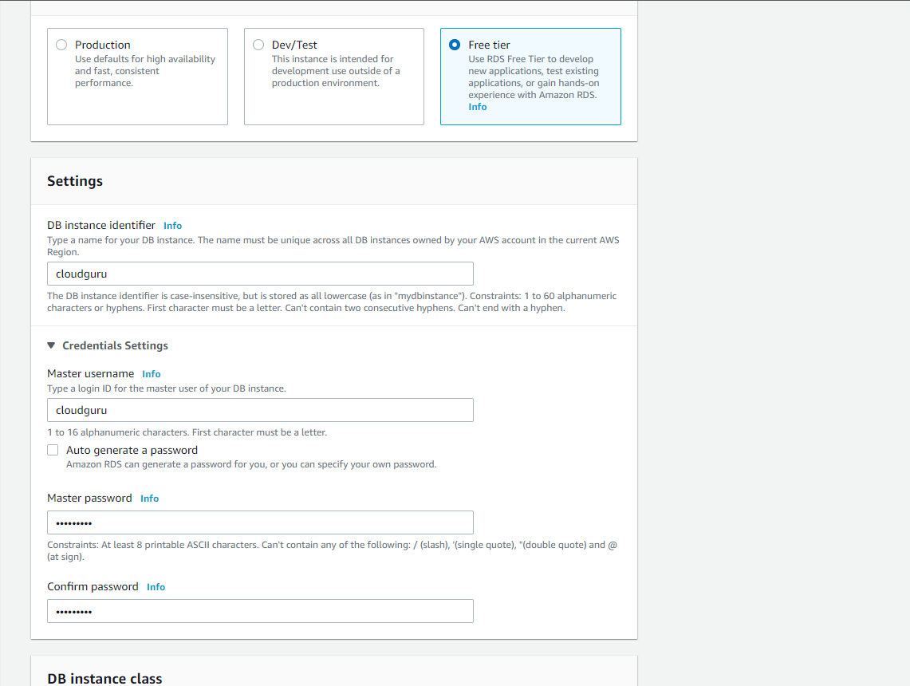

Enable Autos calling

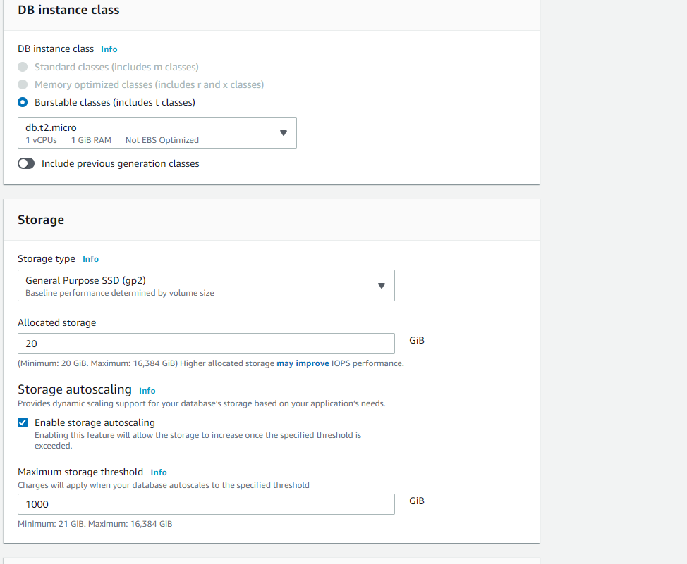

Enable Public access:

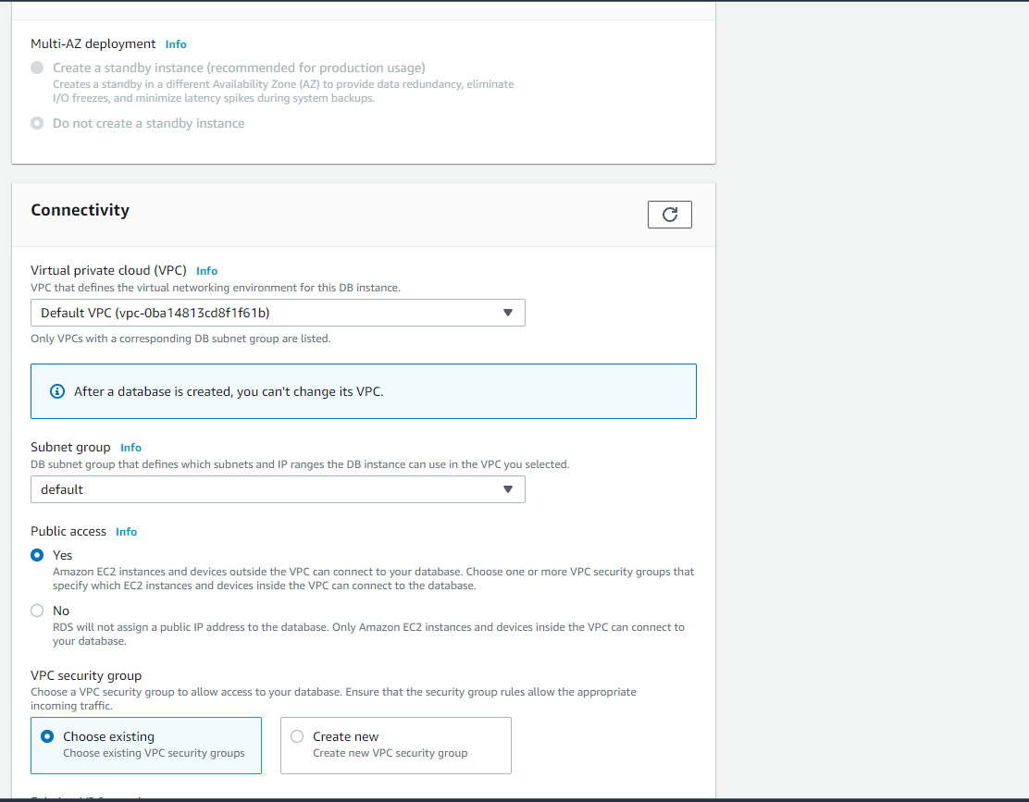

Add RDS security group to allow traffic flowing from EC2 instances:

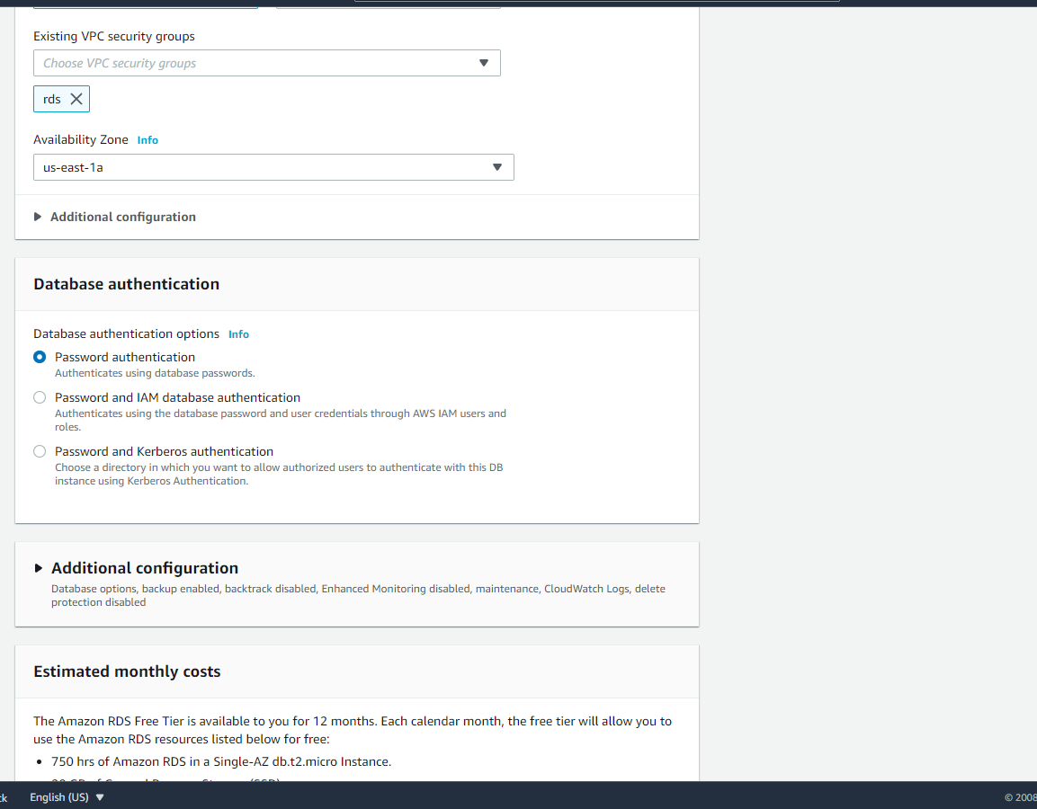

Confirm Database creation

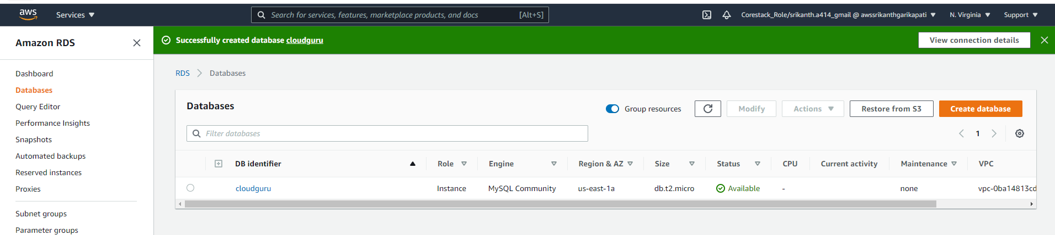

1. Create 2 EC2 instances with Security group websg to allow traffic flowing through LoadBalncer

Create first EC2 instance

Select Amazon Linux instance

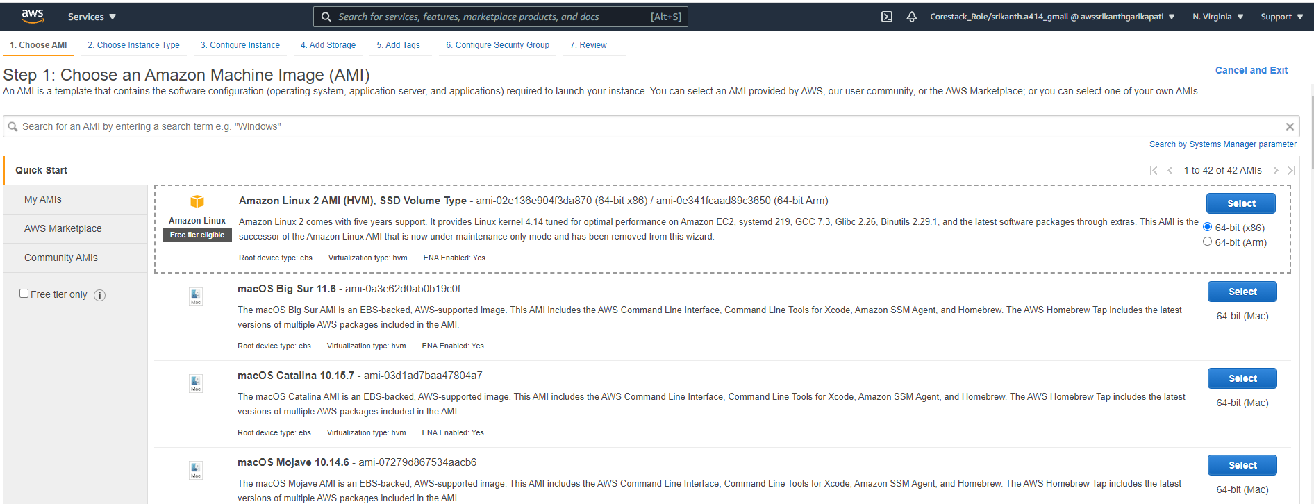

Select t2micro as instance type

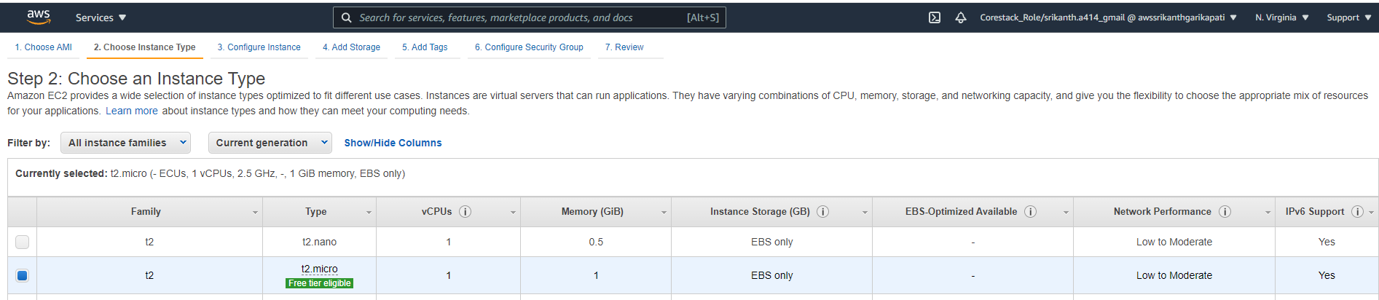

At configuration select zone 1a for the first EC2 instance

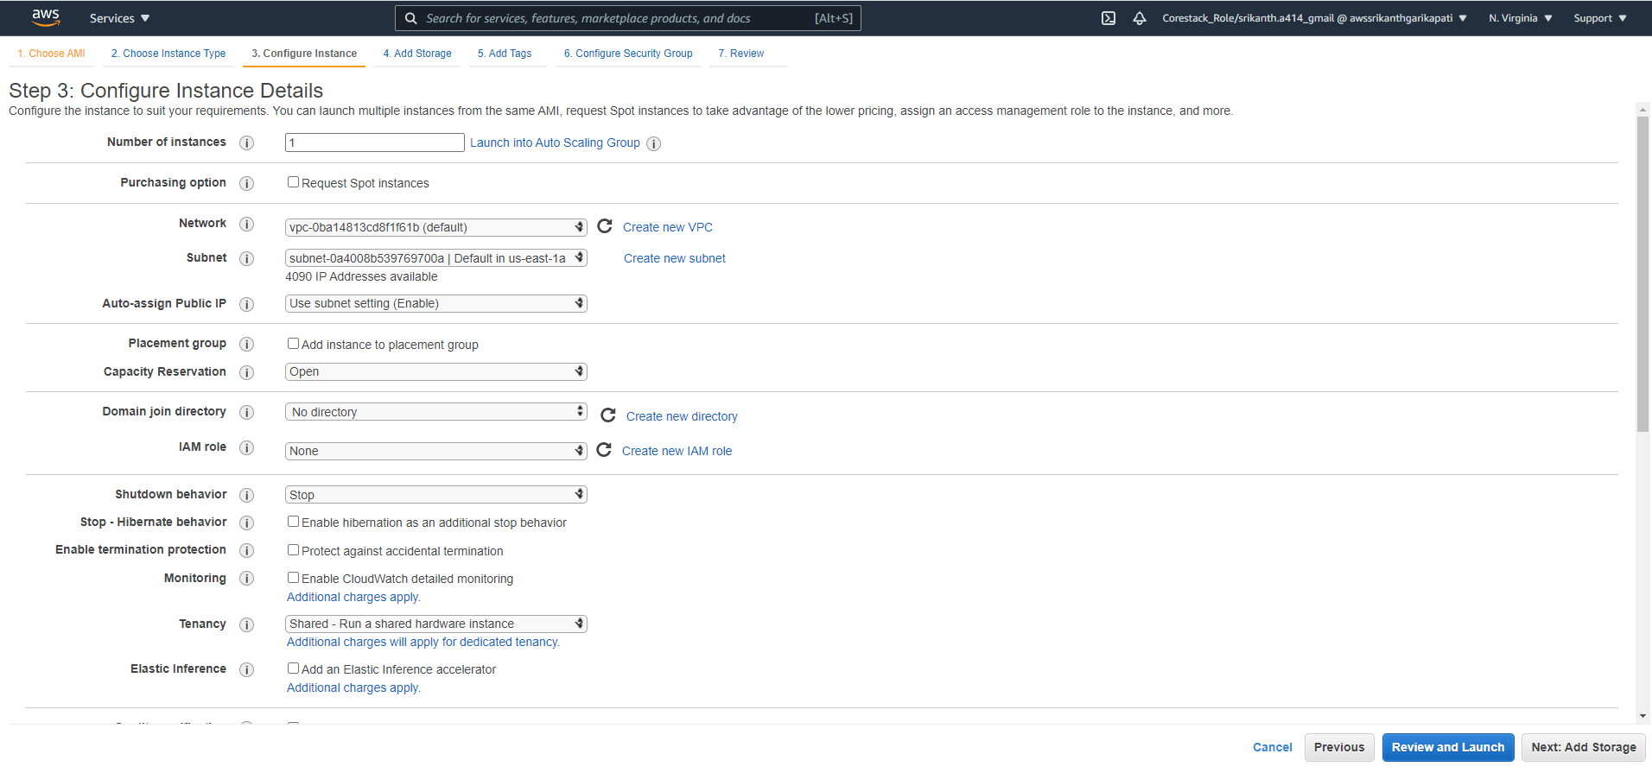

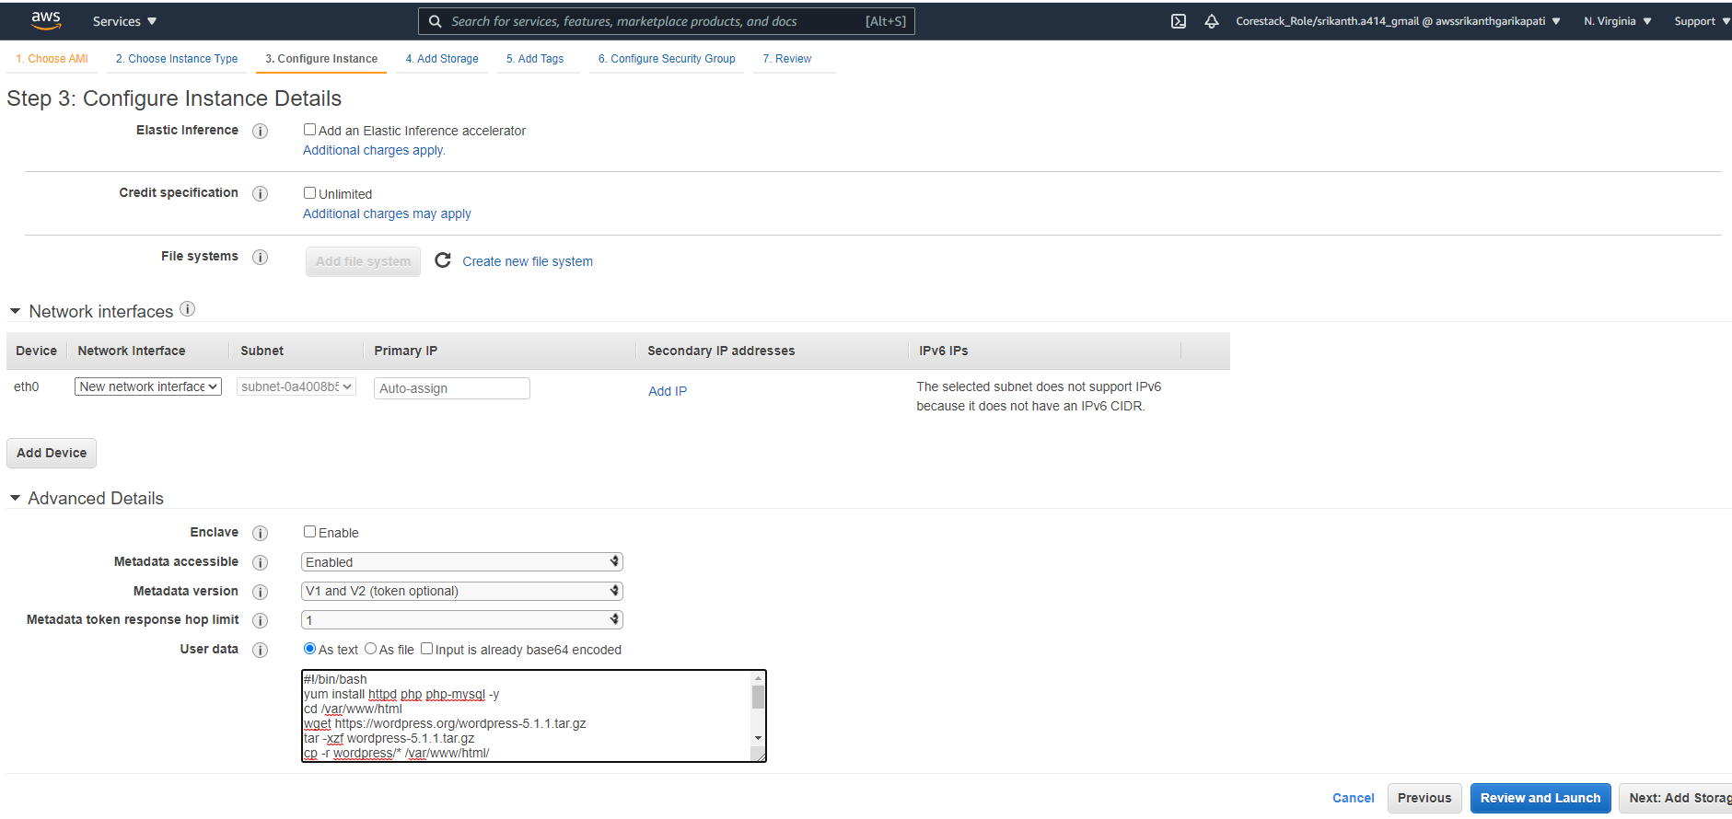

Add storage as General Purpose SSD

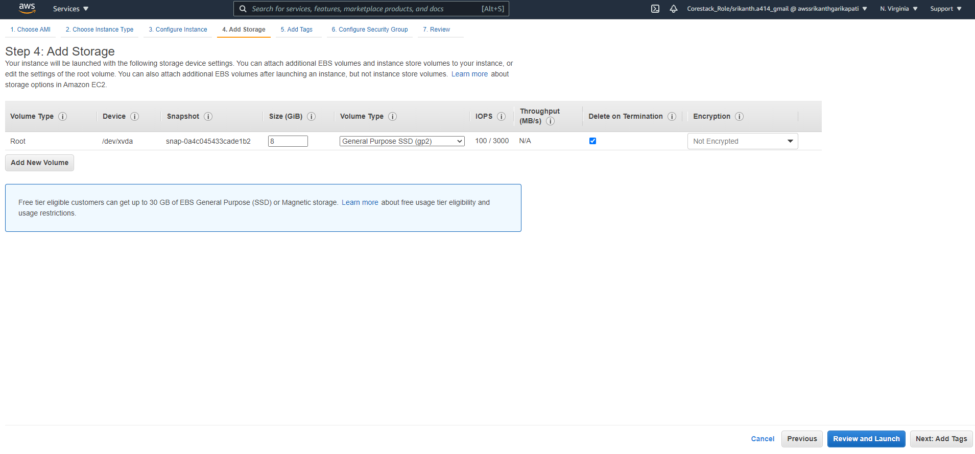

Tag the Instance with the desirable name relevant to project

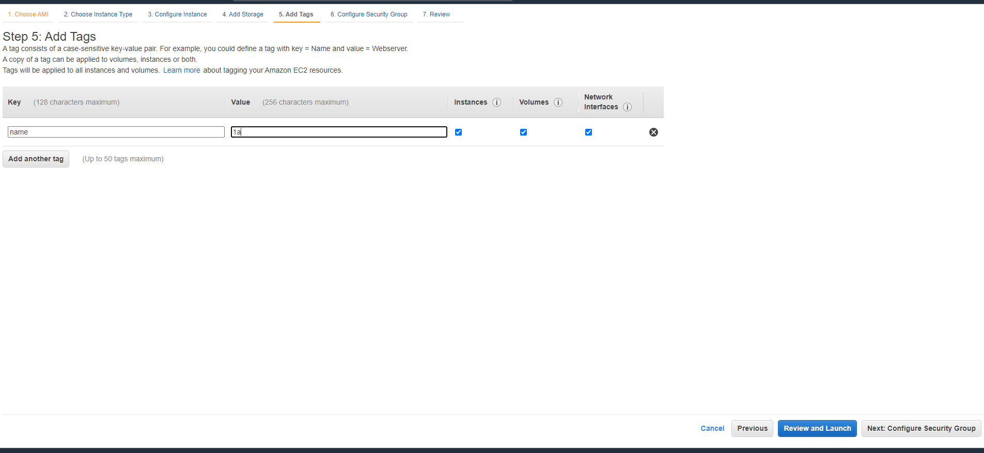

Select websg security group that allows traffic from Load Balancer

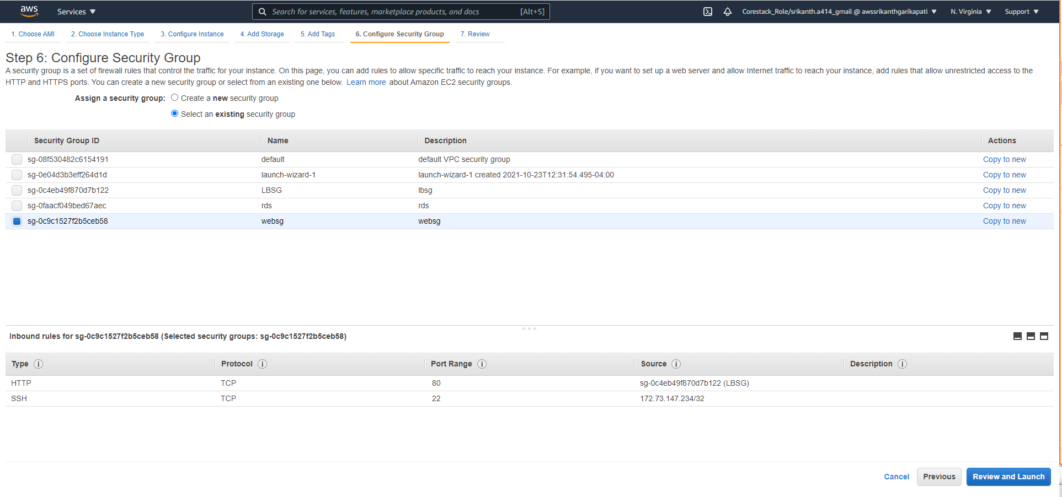

Create a key pair ( for windows machine ) and download it to use to login to EC2 instance

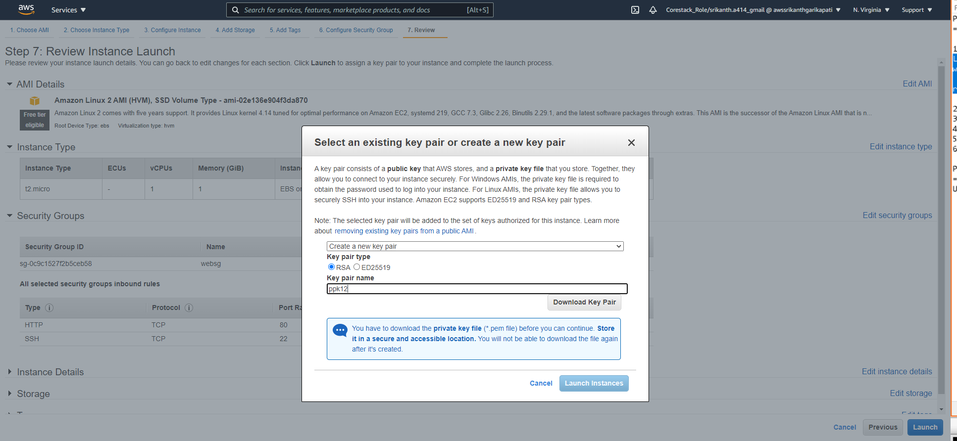

Create 2 EC2 instance

Create second instance and choose Amazon linux instance similar as first Instance created

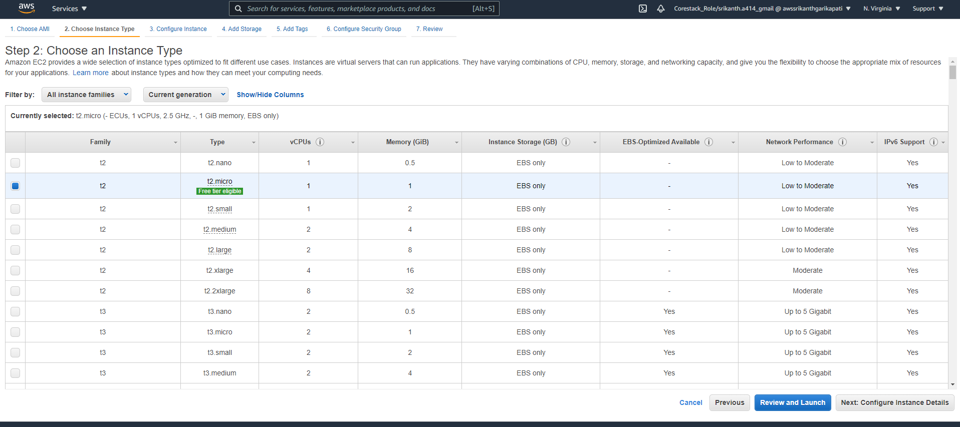

Select zone 1b for the second instance

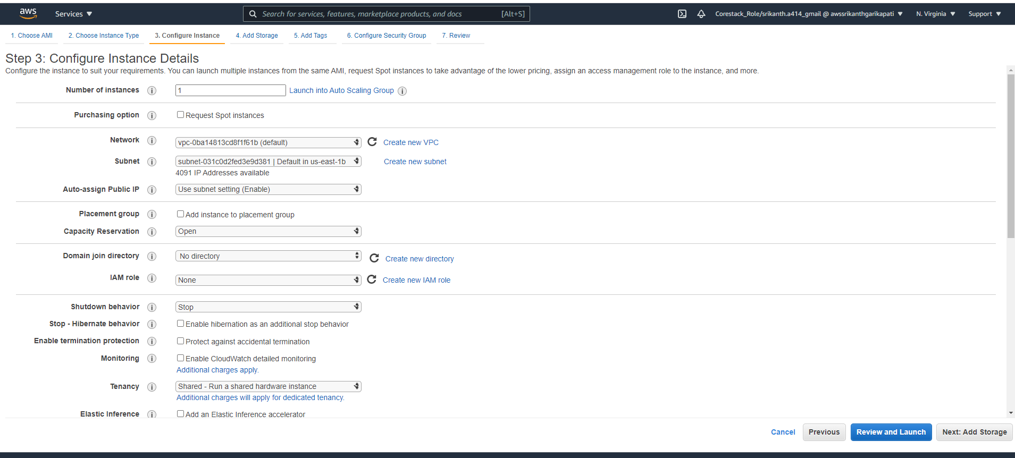

Select storage as General Purpose

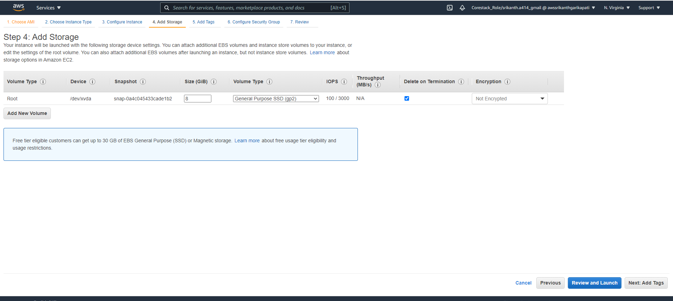

Tag the instance name relevant to the project

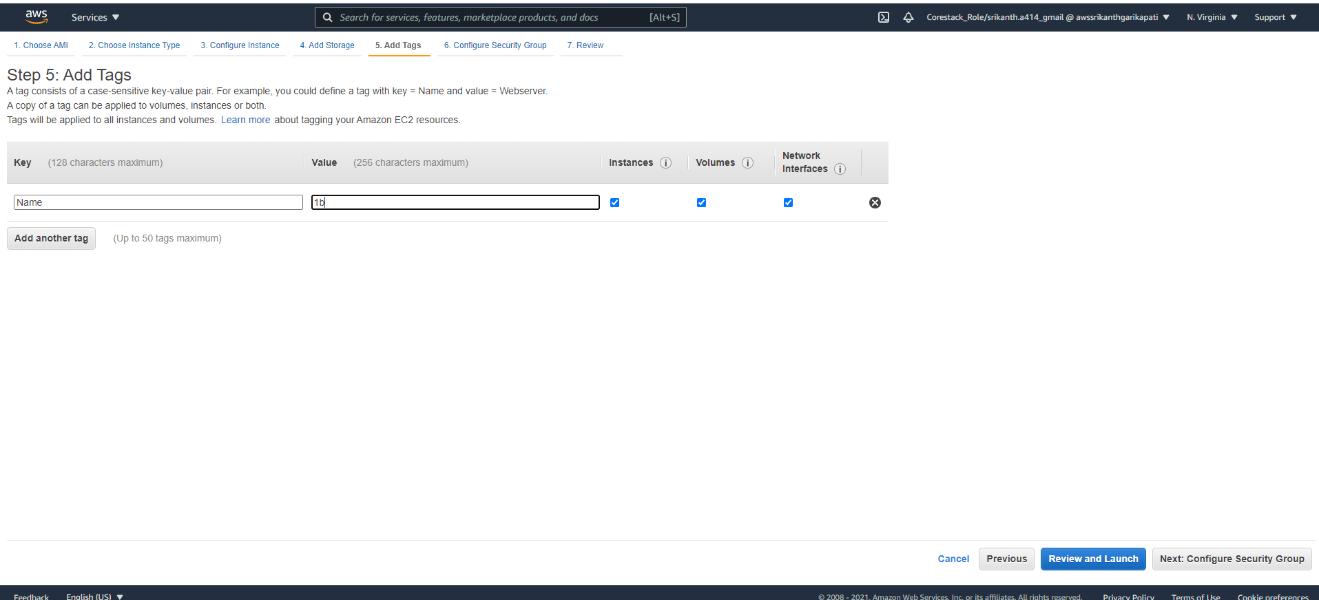

Select security group as websg to allow traffic from Loadbalancer

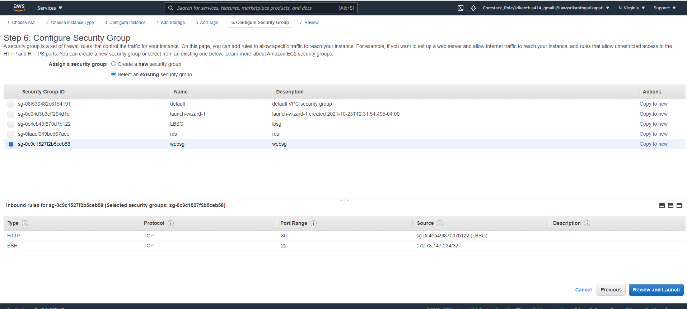

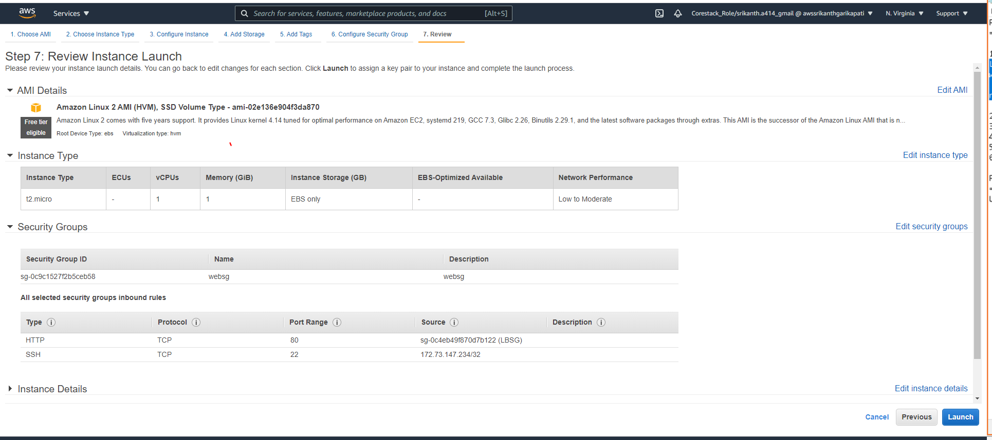

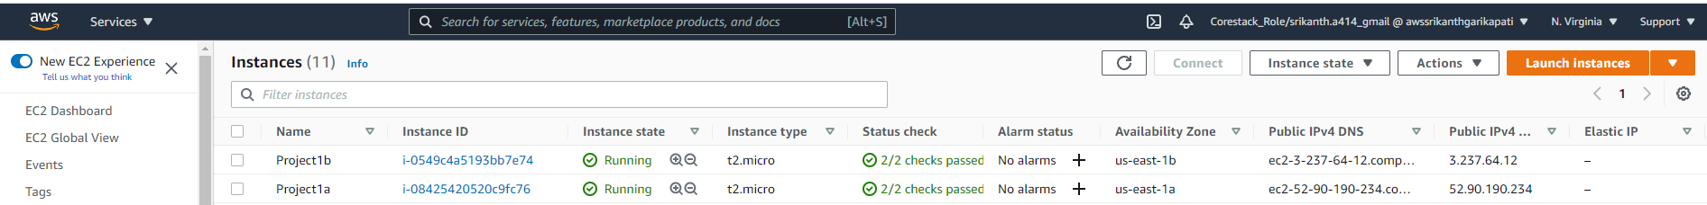

Login to the both instances with SSH authentication using previously downloaded key pair as login password

Create wp-config.php as a root user with the below database details

Create wp-config.php at both the instance with the below script

// ** MySQL settings - You can get this info from your web host ** //

/** The name of the database for WordPress */

define( 'DB_NAME', 'cloudguru' );

/** MySQL database username */

define( 'DB_USER', 'cloudguru' );

/** MySQL database password */

define( 'DB_PASSWORD', 'cloudguru' );

/** MySQL hostname */

define( 'DB_HOST', 'cloudguru.chw3nz25fbse.us-east-1.rds.amazonaws.com' );

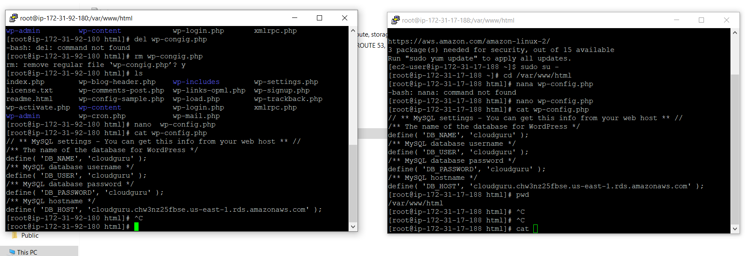

1. Create Target Group and LoadBalancer with security group lbsg:

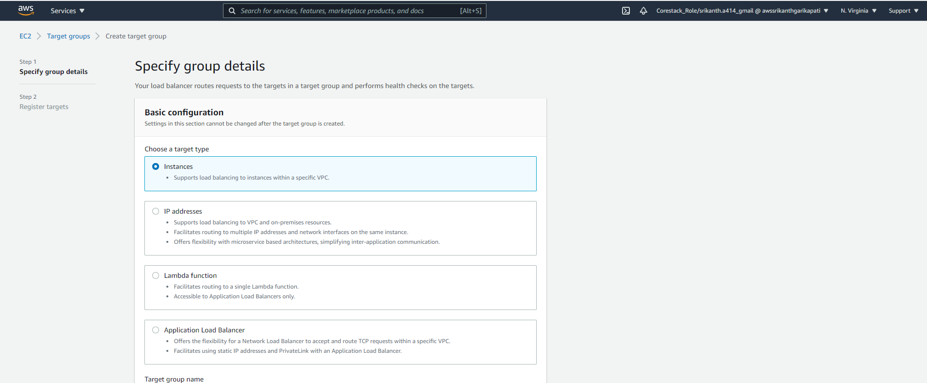

Provide target group name and Protocol

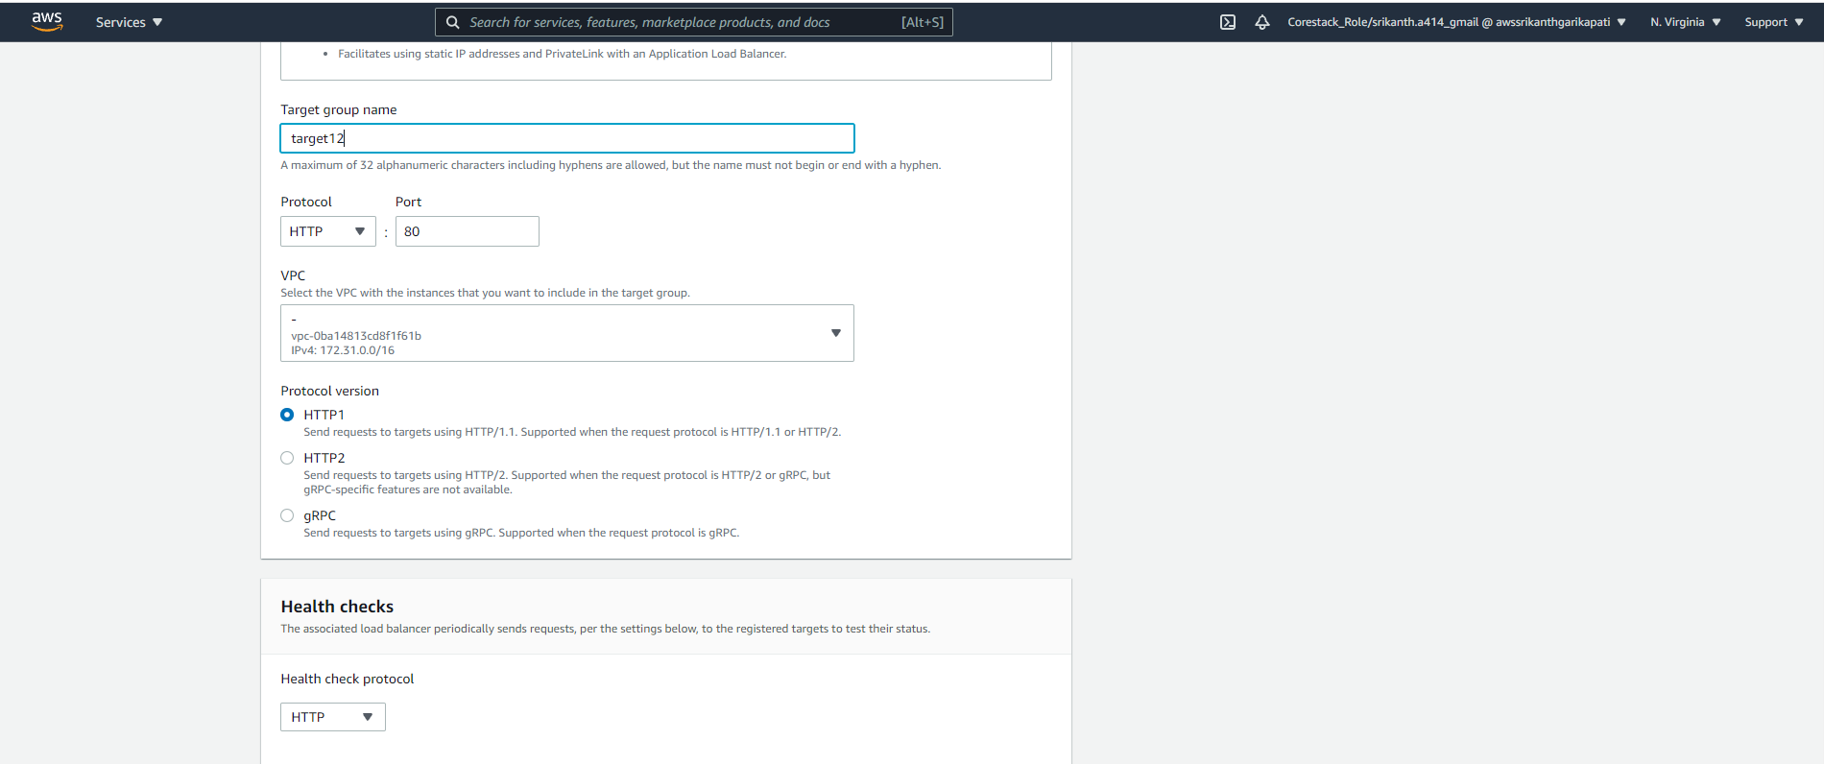

Provide healthcheck path as root

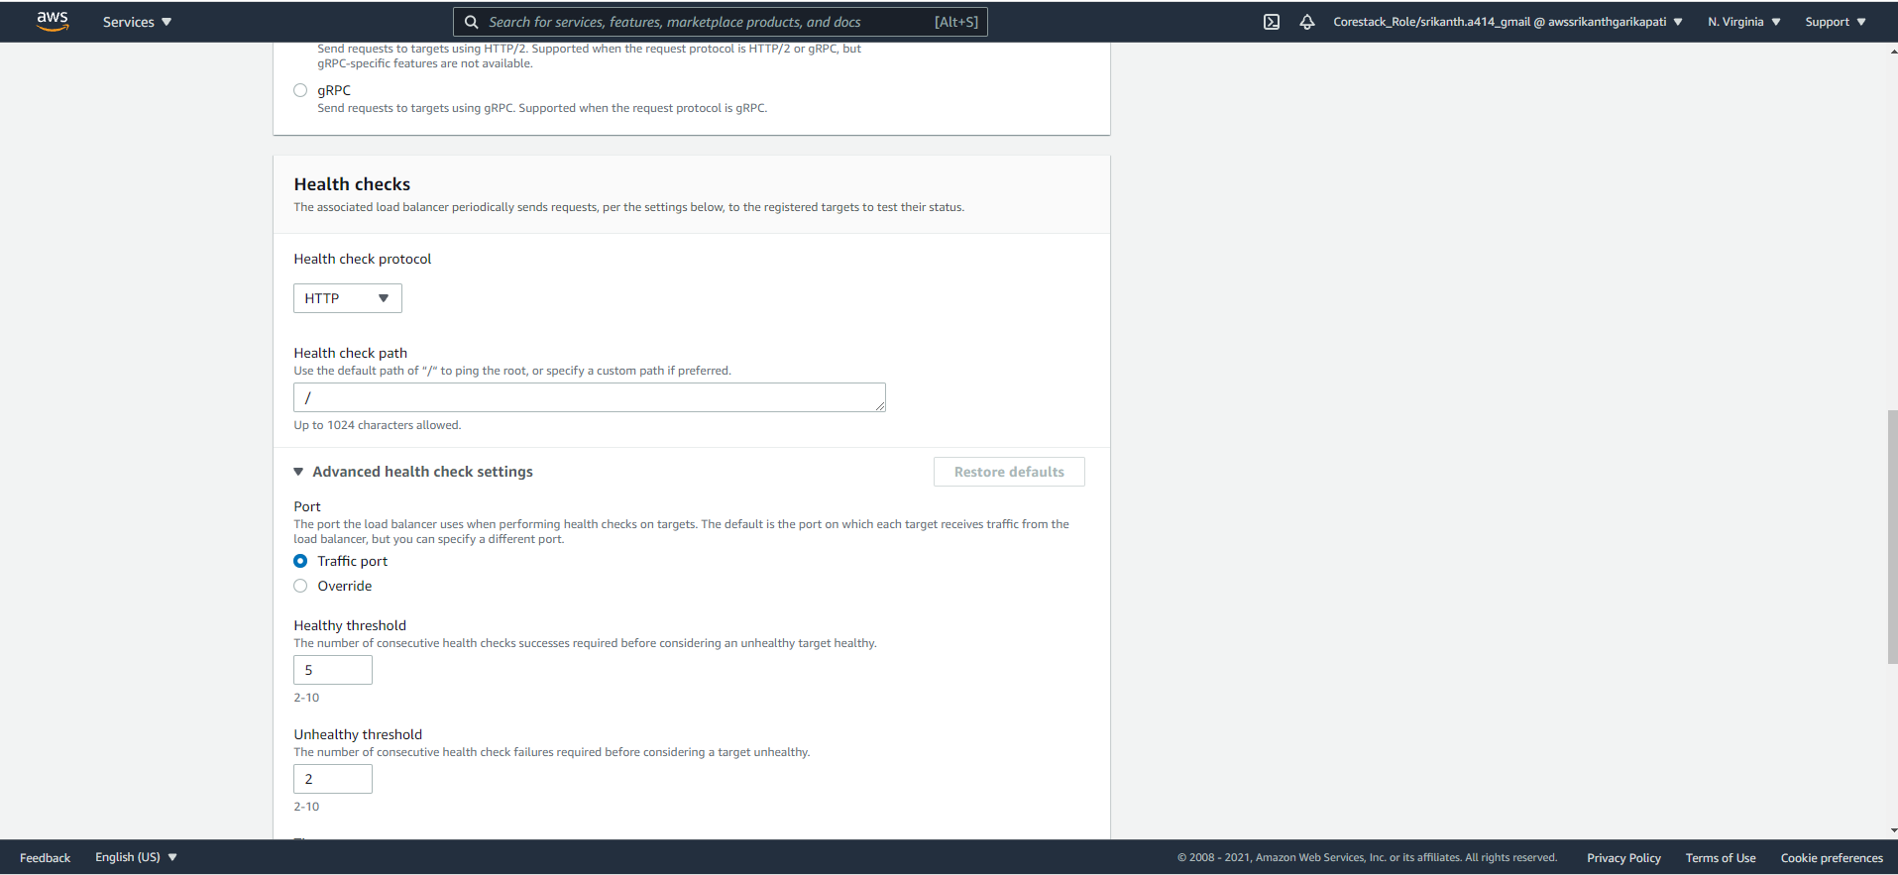

Provide Health threshold as 3 and interval as 10 seconds

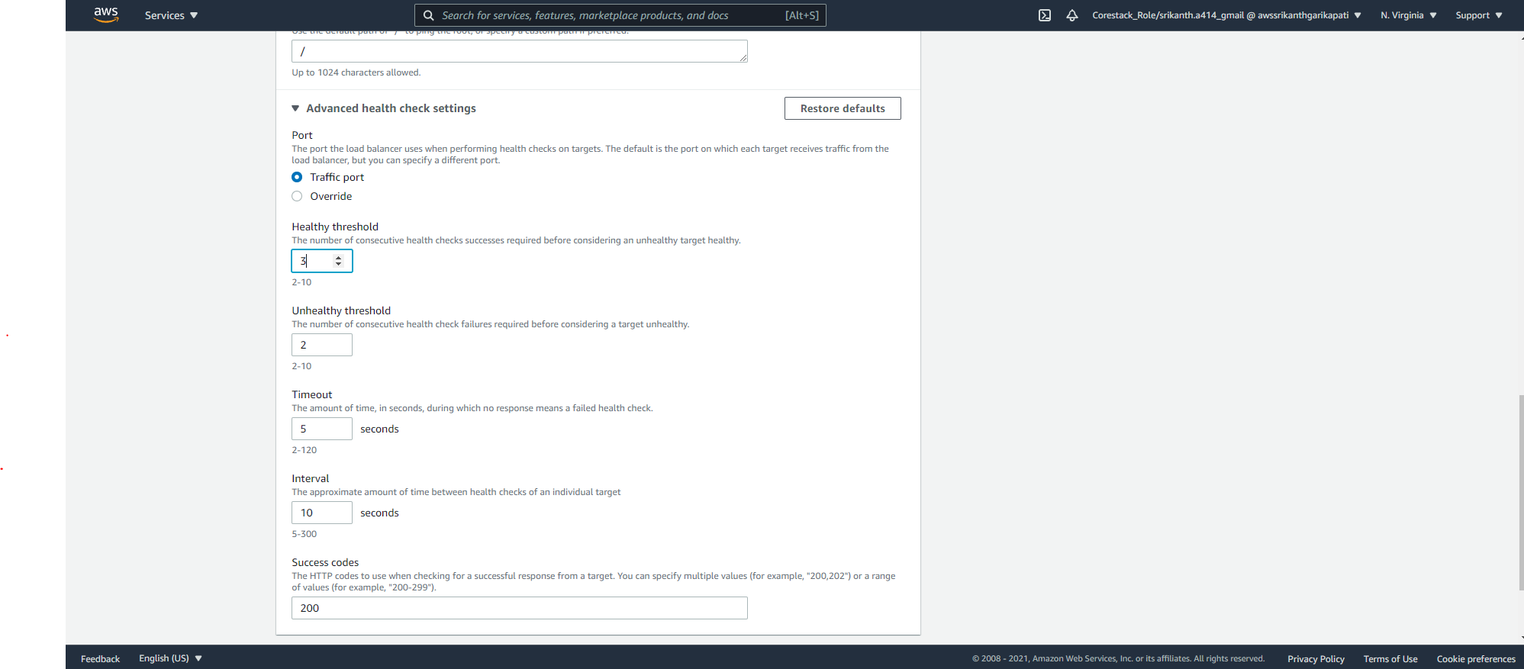

1. Register instances for target group target12 and add as include as pending below and create target group:

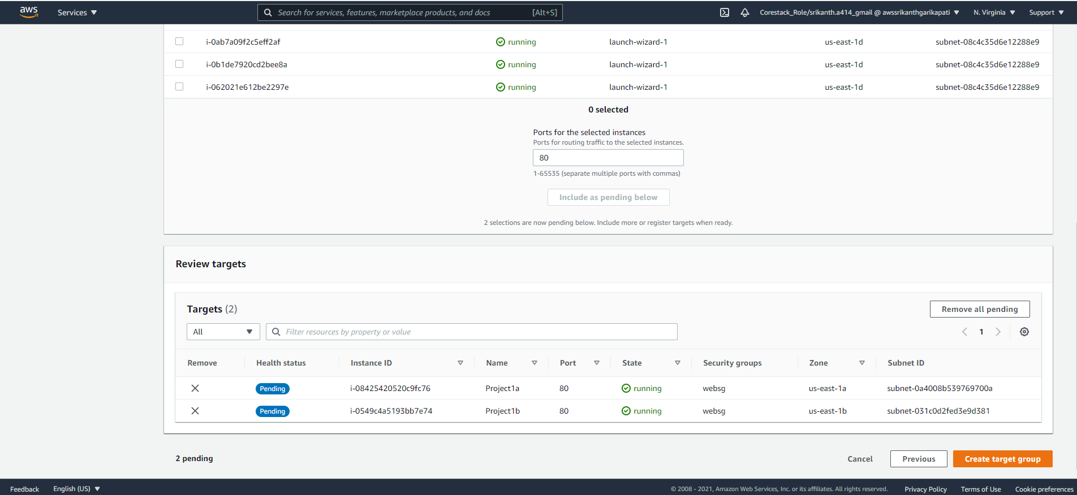

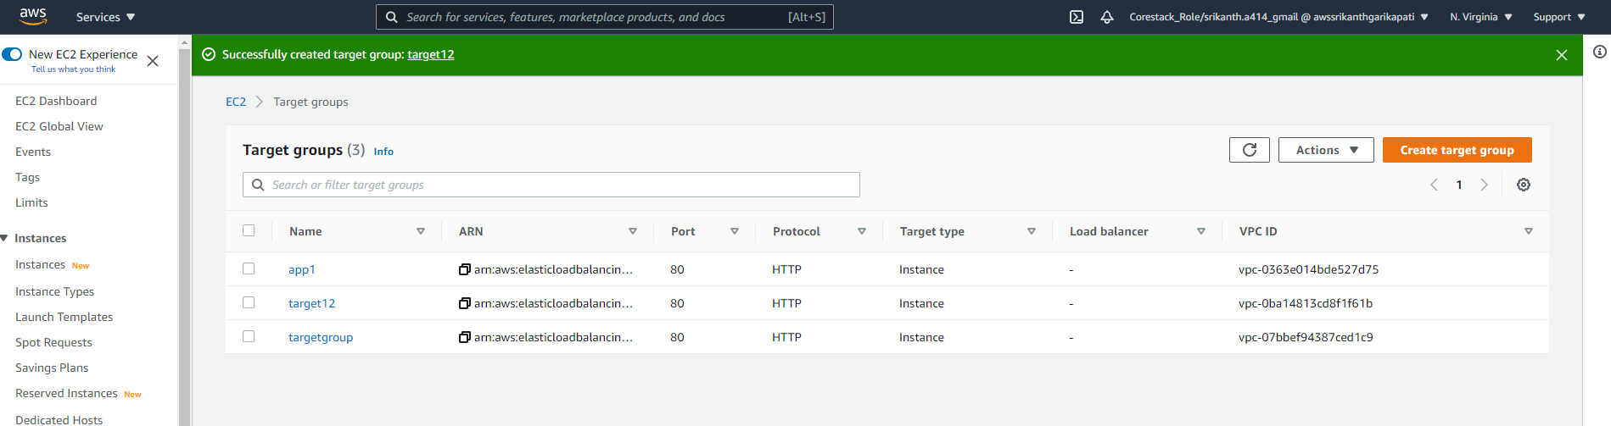

1. Create Application LoadBalancer LB12

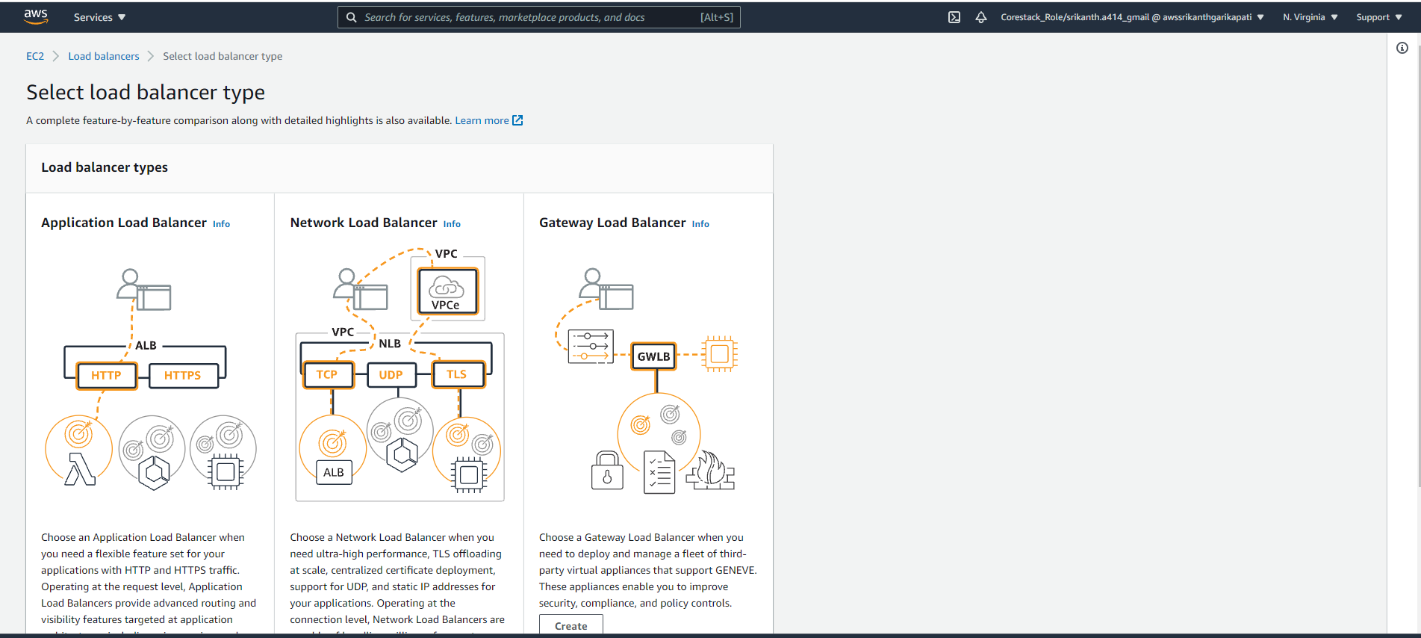

Select Load balancer as internet facing:

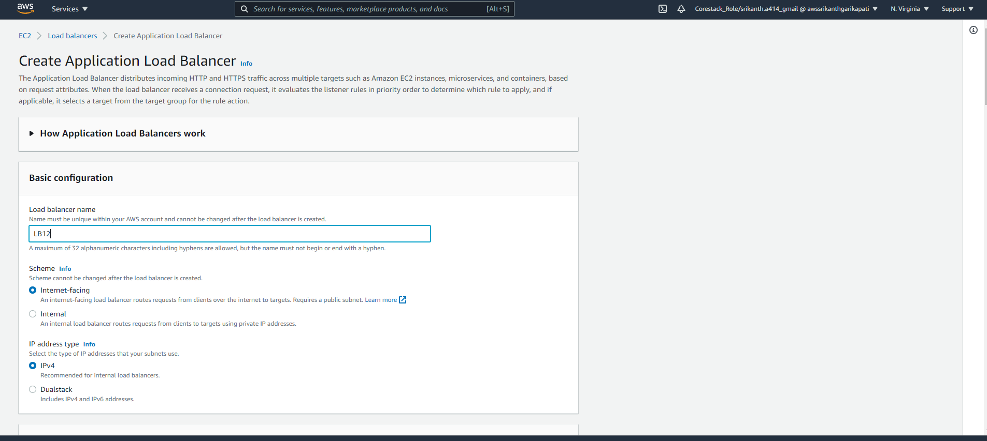

Select all the available zones for the Load Balancer

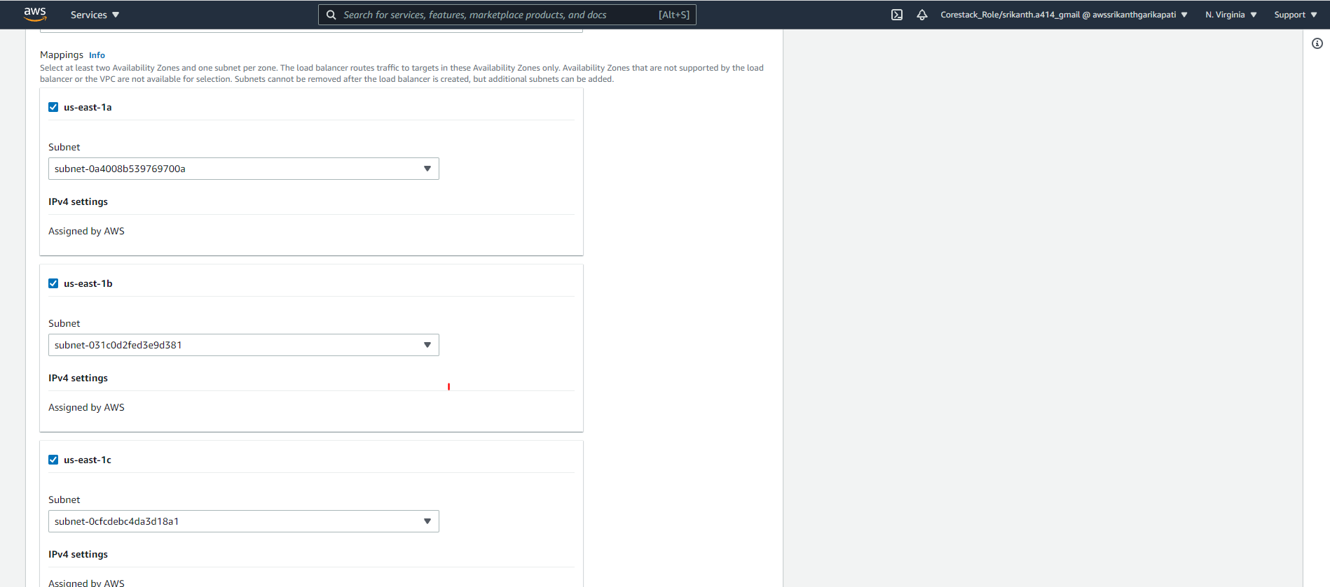

Select security group LBSG and remove default security group:

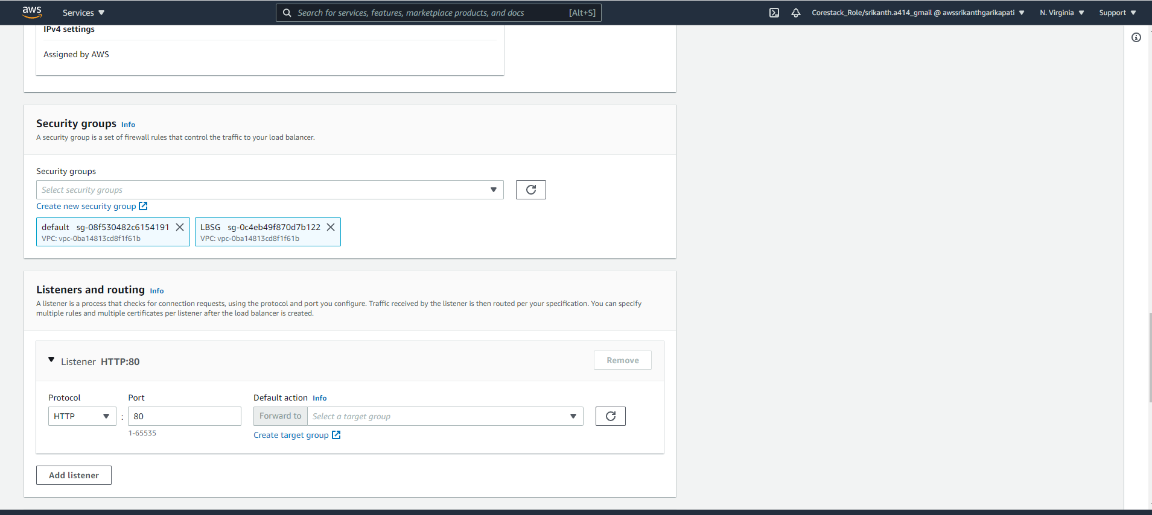

Configure newly created target group target12 as Listener

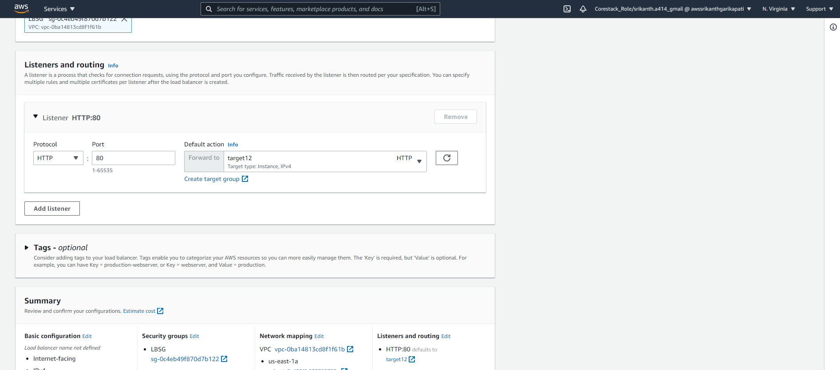

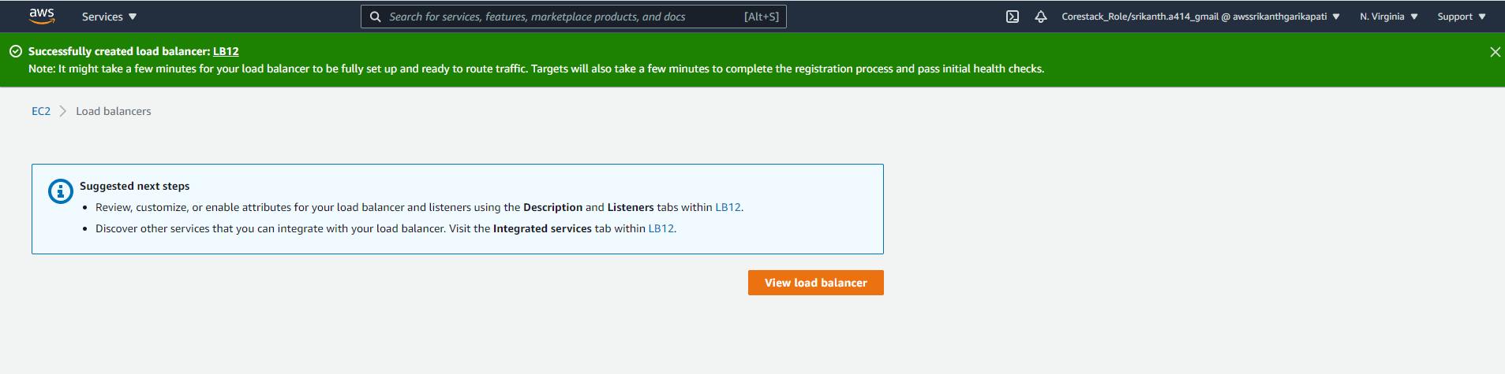

Copy the DNS name from Loadbalaner and see if you can access wordpress Page

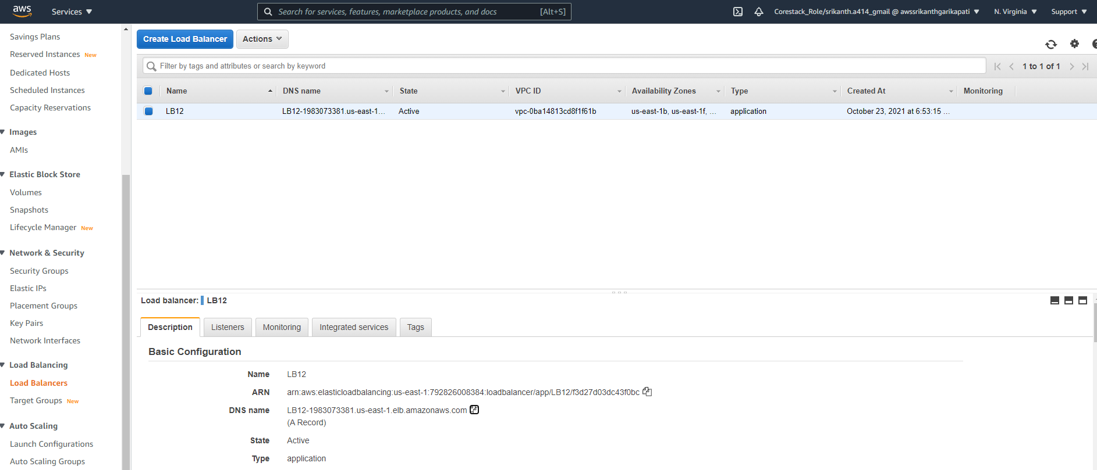

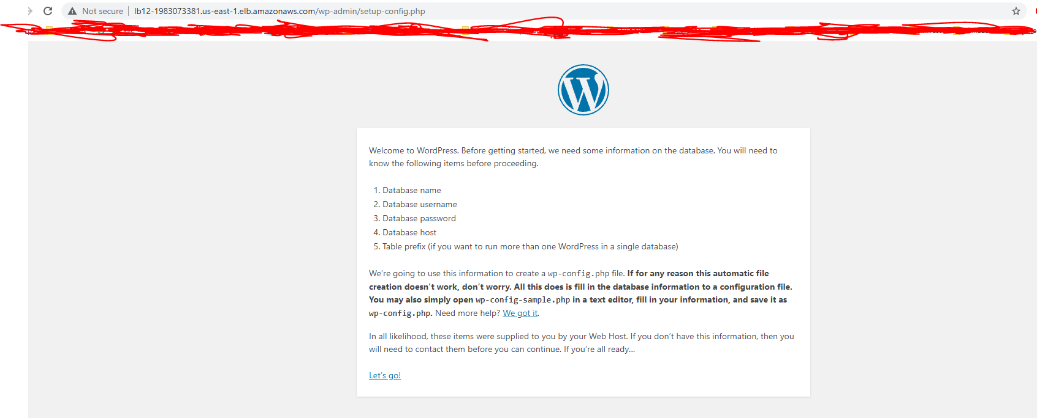

Login to database with the credentials:

